COM S 319: Homework 2 Report

The first thing that I created was a title and a header for the validation form - page 1.

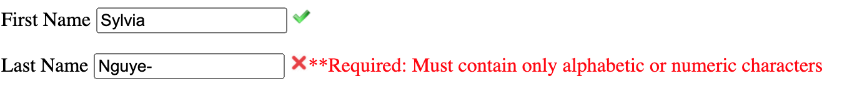After that, I started focusing on creating an input for first name and last name. On the HTML side, it would be the input id with type being text. On the JS side, I first created the function alphanum to check if the name only consists of letters and number as describe on the rubric. The function would return a Boolean, true if it meets the requirement, false otherwise. I created a get Image function to use that Boolean to get the right image for the name input. I also created a getNotificationName function that display an error message. Result when hitting the continue button after entering invalid information:

Last Name is incorrect because “– “does not meet the requirement for this assignment when it comes to name

First Name is incorrect because “– “ does not meet the requirement for this assignment when it comes to name

After that, I created the gender drop box and the state drop box on the html file using select id. In JS, I would just put the set the getimage to true to get the checkmark, since on the discussion board the TA said we can assume that the drop box will always be correct.

If all of the information is entered correctly it would go to the next page when hit the continue button.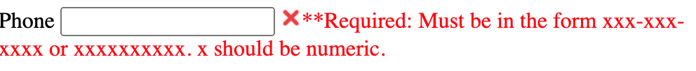

For the email, on the HTML side I use the input id with type being text for the user to enter their email. On the JS side, I created emailcheck function to check if the email is input in a correct format, which will return a Boolean, true if input correct, false if input incorrectly. Then I will use the Boolean to display the corresponding image and a message if the input is incorrect.

For the Phone, on the HTML side I use the input id with type being text for the user to enter their phone number. On the JS side, I created phonecheck function to check if the phone input in a correct format, which will return a Boolean, true if input correct, false if input incorrectly. Then I will use the Boolean to display the corresponding image and a message if the input is incorrect.

For the Address, on the HTML side I use the input id with type being text for the user to enter their address. On the JS side, I created addresscheck function to check if the address input is in a correct format, which will return a Boolean, true if input correct, false if input incorrectly. Then I will use the Boolean to display the corresponding image and a message if the input is incorrect.





This is what it looks like when all of the information is enter correctly for contact information page:

